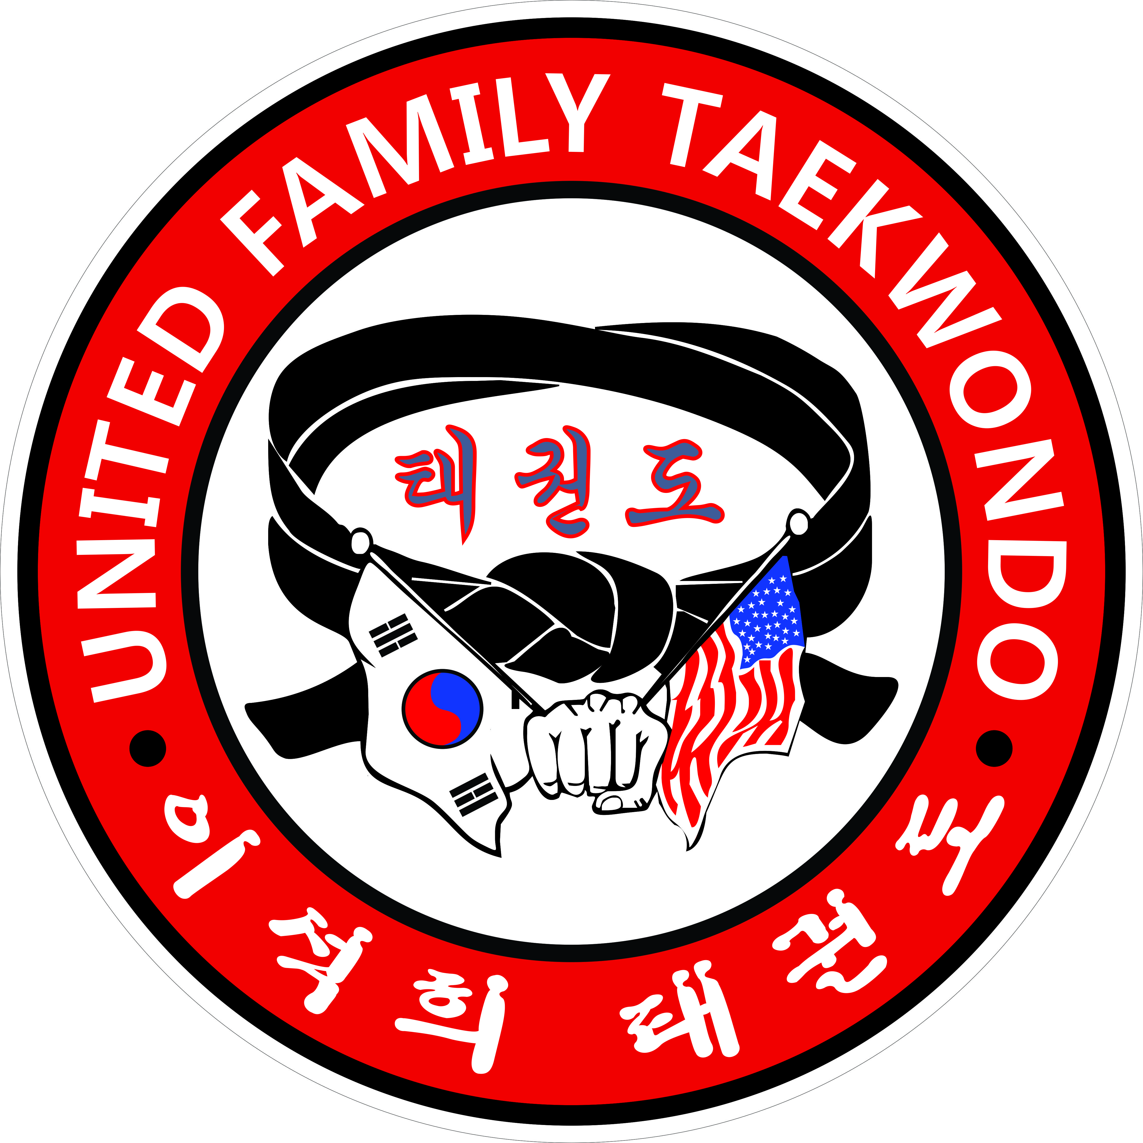
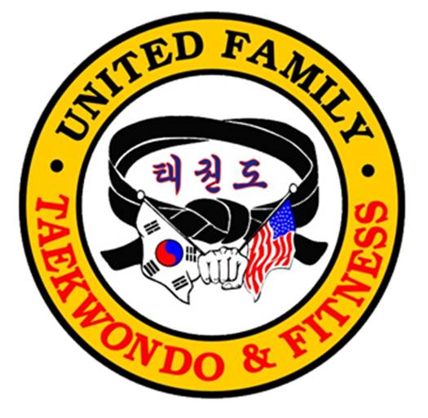
GRAND MASTER LEE’S
UNITED FAMILY TAEKWONDO
“BLACK BELT IS A WHITE BELT WHO NEVER QUITS”
“COMMITMENT TO EXCELLENCE”

COVID 19 Q and A
- Do you or anyone in your family have any flu like symptoms? Yes No
- Do you or anyone in your family have fever, chills, cough, shortness of breath, body aches? Yes No
- Do you have a significant chronic illness or compromised immune system? Yes No
- Have you or anyone in your family traveled out of state in the past month? Yes No
- Have you been previously asked to self-isolate or self-quarantine at home? Yes No
- Have you had close contact to an individual diagnosed with the COVID-19 infection? Yes No
- Have you been recently rested for COVID-19? Yes No
If yes, have you received results that you tested negative for COVID-19? Yes No
Any other medical history changes? (Please clarify) ______________________________________________________________________________________________________________________________________________________________________________

CONSENT FORM FOR UFT CLASS TRAINING

I, ____________________________ knowingly and voluntarily assume all risk for myself and/or my minor child __________________________ involved in and participation of instructed classes at United Family
Tae Kwon Do and acknowledge that there are increasing risk of exposure to Covid-19 during the visit.
I understand that I must comply with all set procedures to reduce the spread while attending my classes.

I fully confirm that I have not tested positive for COVID-19 nor do I have any symptoms currently related to COVID-19. I am also truthfully stating that I have not traveled outside the US in the last 4 weeks, nor have had any contact with anyone who may have any symptoms concurrent with COVID-19, including but not limited to fever, cough, nausea, diarrhea, vomiting, shortness of breath, etc. I acknowledge that I must comply with all set procedures school rules to reduce the spread while attending my classes.

THIS LIABILITY WAIVER AND RELEASE

I hereby release and agree to hold United Family Taekwondo harmless from and waive on behalf of myself, my heirs, and personal representatives any and all cause of action, clams, demands, damages, costs, expenses and compensation for damage or loss to myself and/or property that may be caused by any act, or failure to act of the school, or that may otherwise arise in any way in connection with any services received from United Family Taekwondo. I understand this release discharges United Family Taekwondo from any liability or claim that I, my heirs, or any personal representatives may have against the school with respect to any bodily injury, illness, death, medical treatment, or property damages that may arise from, or in connection to, any services received from United Family Taekwondo. This Release extends to favor of United Family Tae Kwon Do, Master Steve Lee and, current school Instructors, staff members, other students and participants. __________ (Initial)

PARENT SIGNATURE: _____________________________ DATE: _______________________

